Module Name: Automation Exercise
Test Case ID: 2
Webpage URL: https://www.automationexercise.com

Scenario ID: 1
Scenario: Sign up with valid credential (valid ID, Password)
Test Steps:
1. Open the Website and register in website
2. Enter username and email ID
3. Enter Account Information
4. Enter Address Information
5. Click Create Account Button
Screenshots :

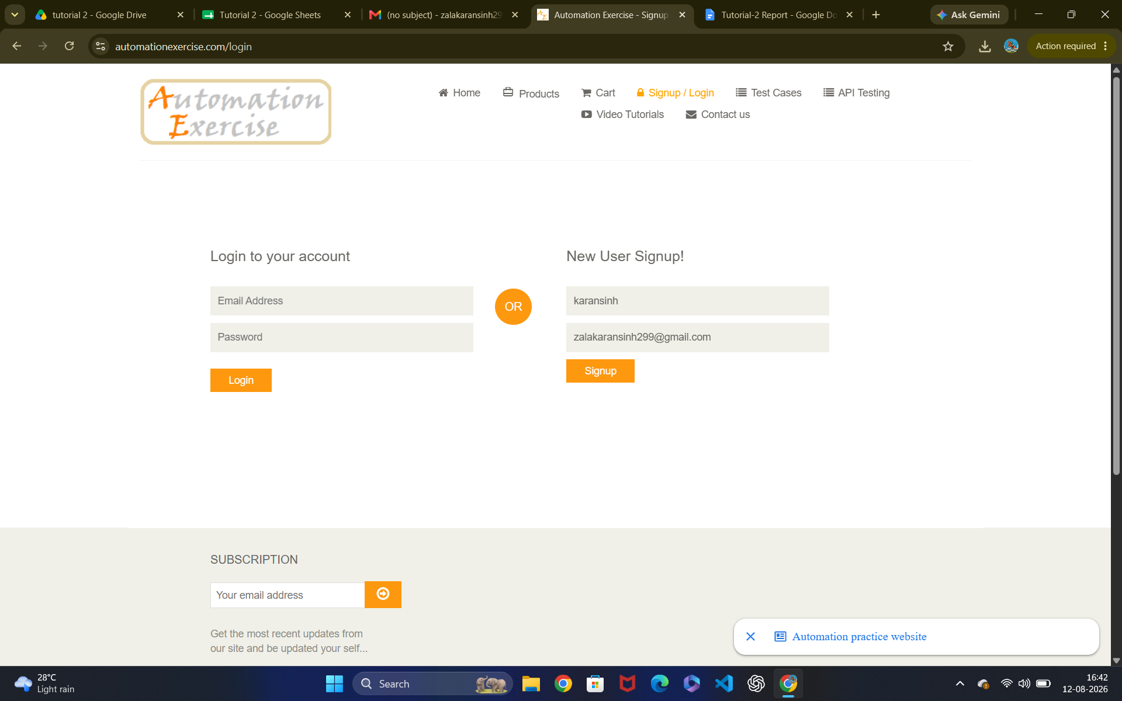

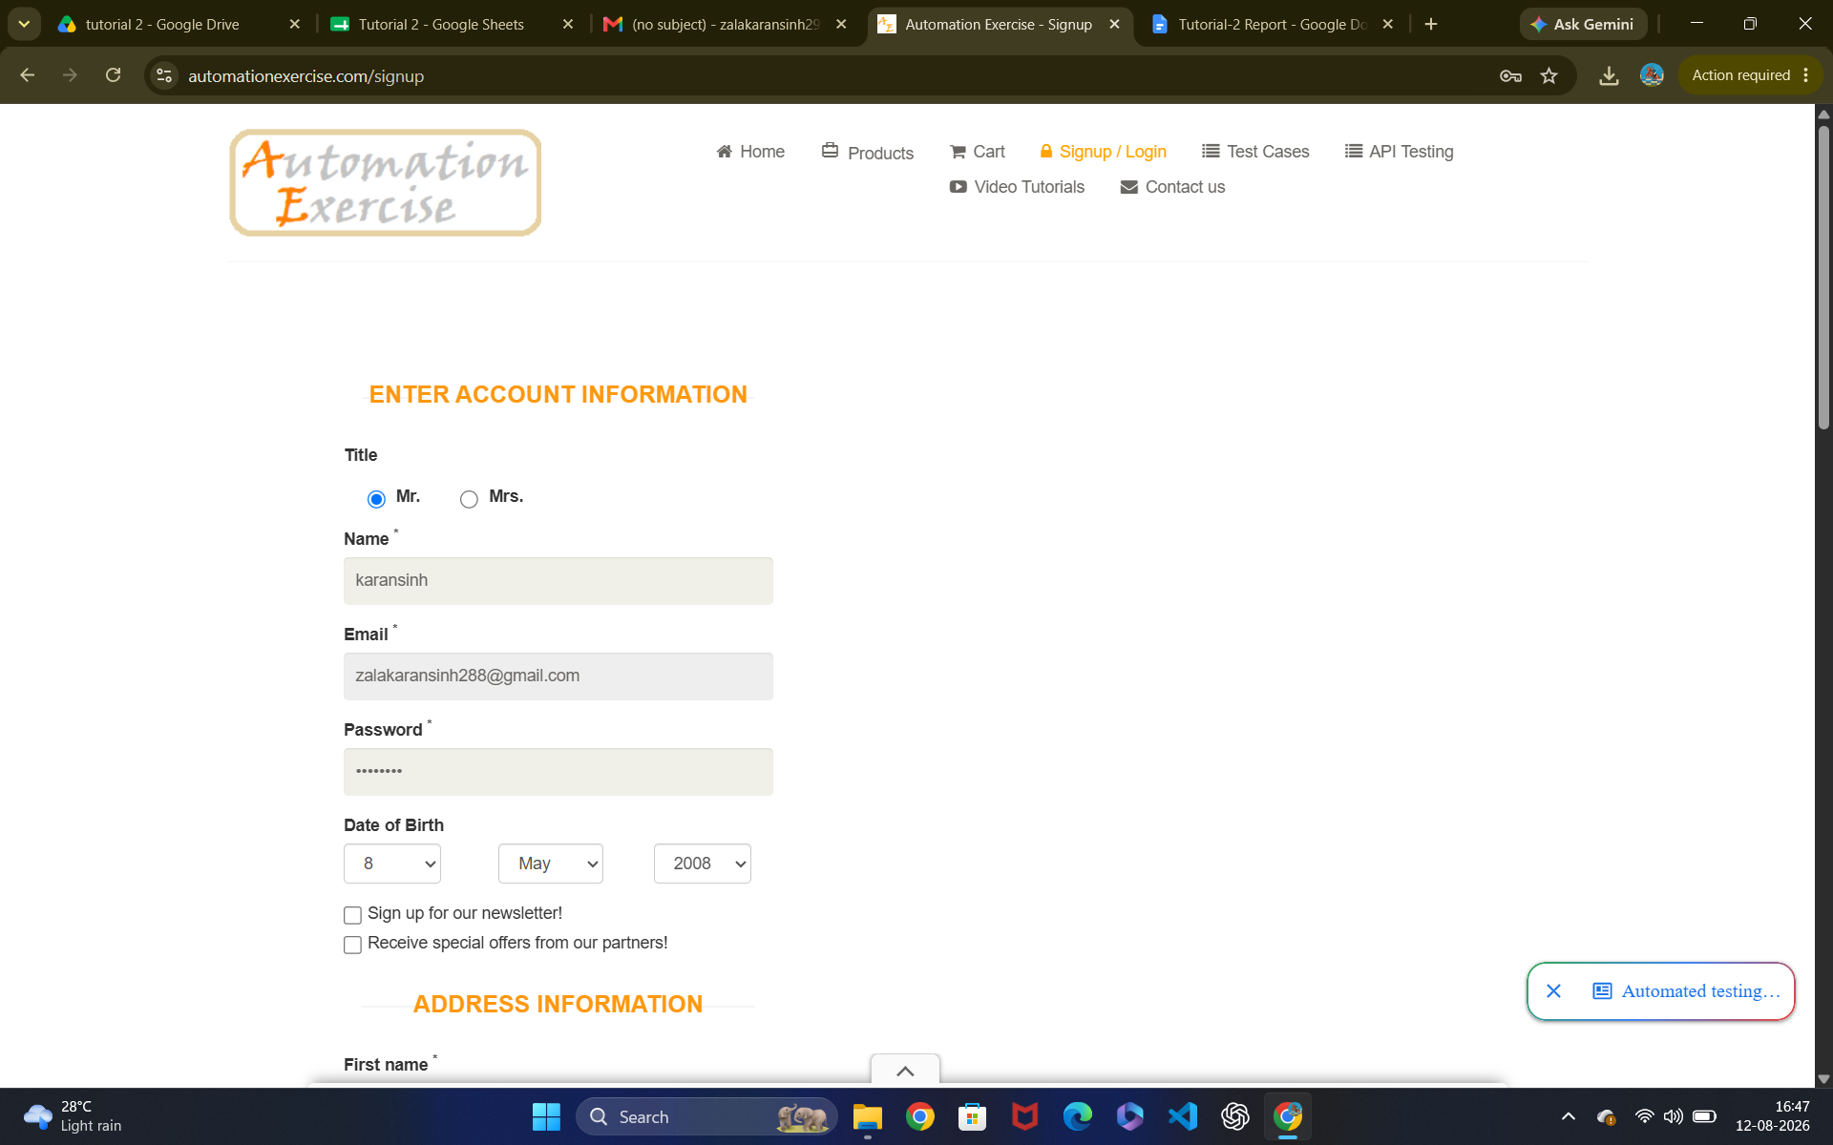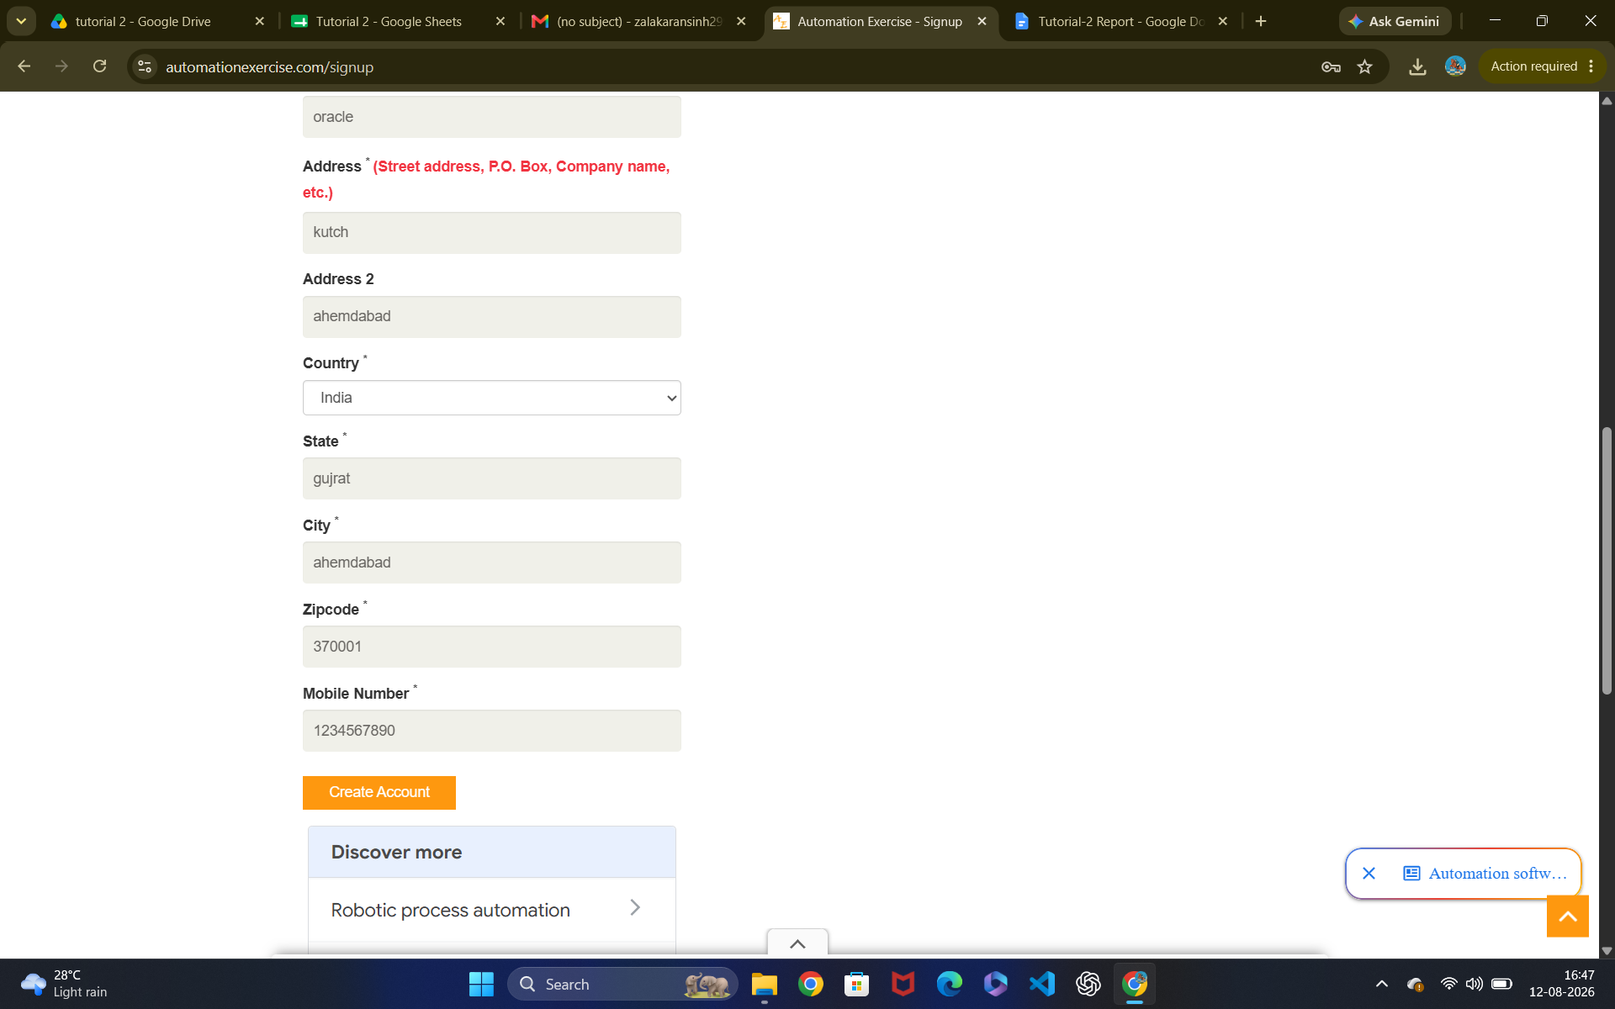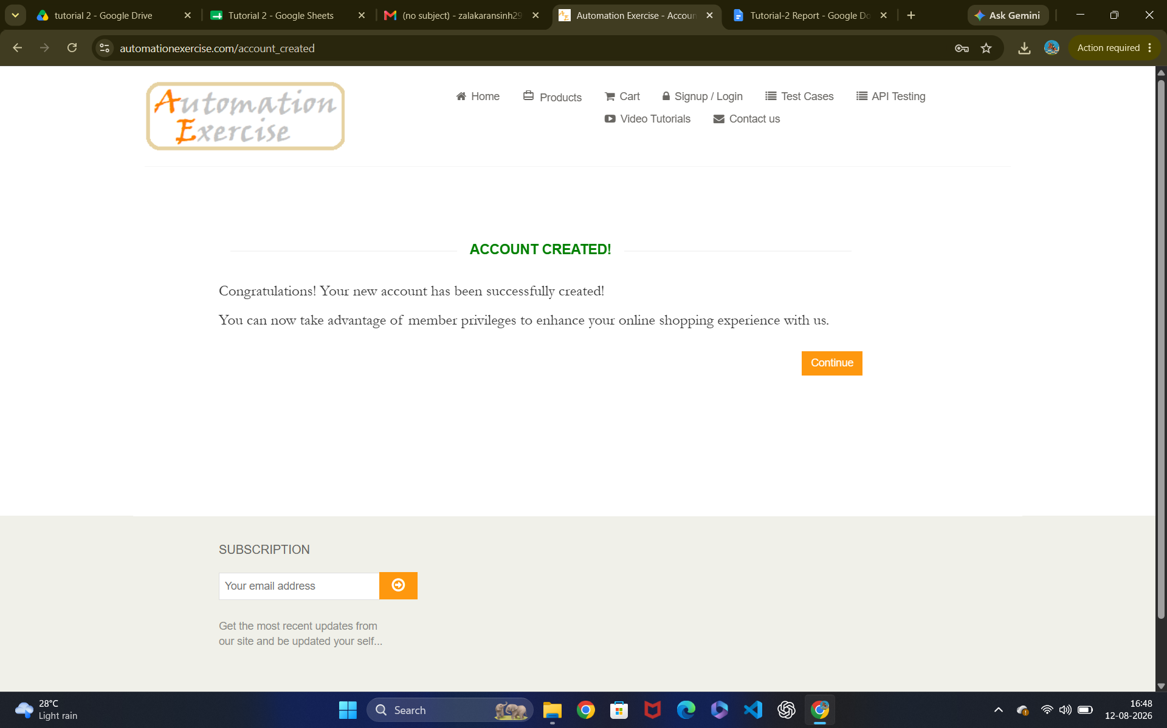

- Scenario ID: 2
Scenario: Sign up with invalid credential (invalid ID, Password)
Test Steps:
1. Open the Website and register in website
2. Enter username and email ID
3. Enter Account Information
4. Enter Address Information
5. Click Create Account Button
Screenshots: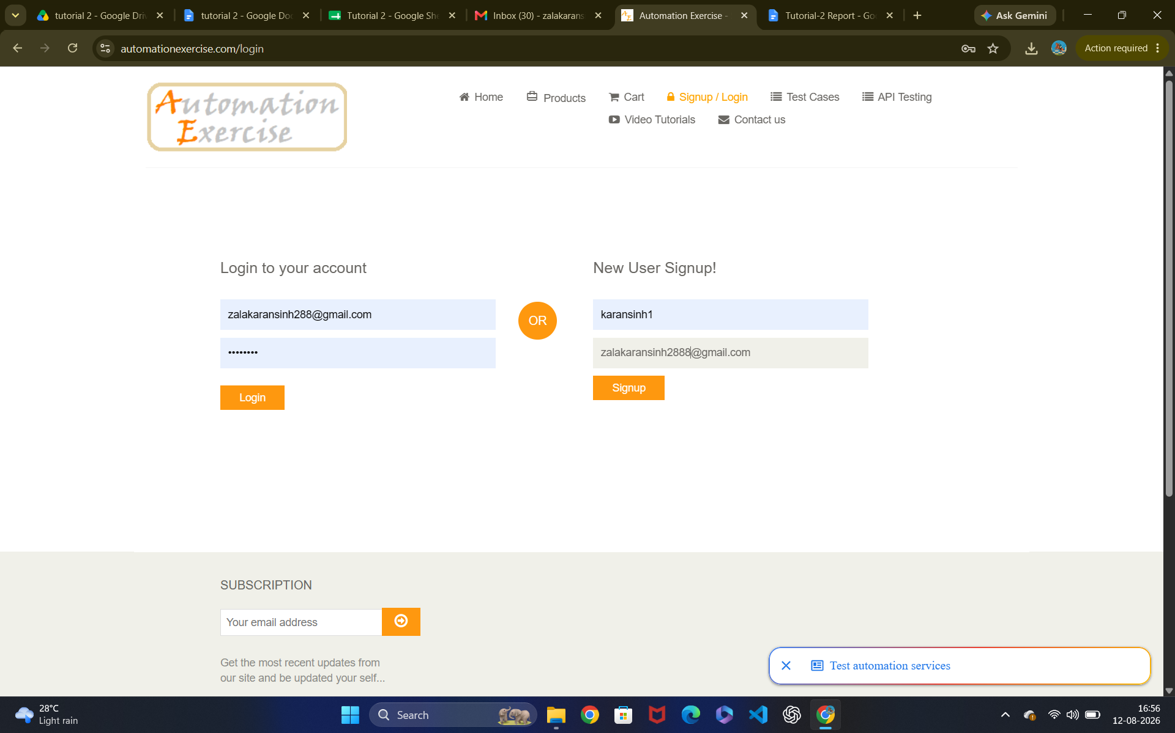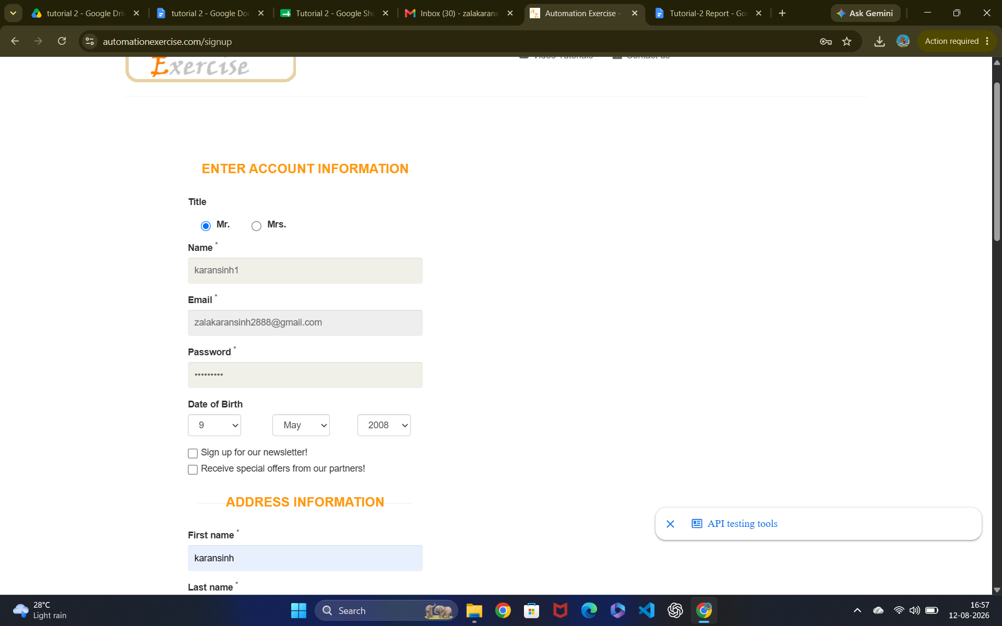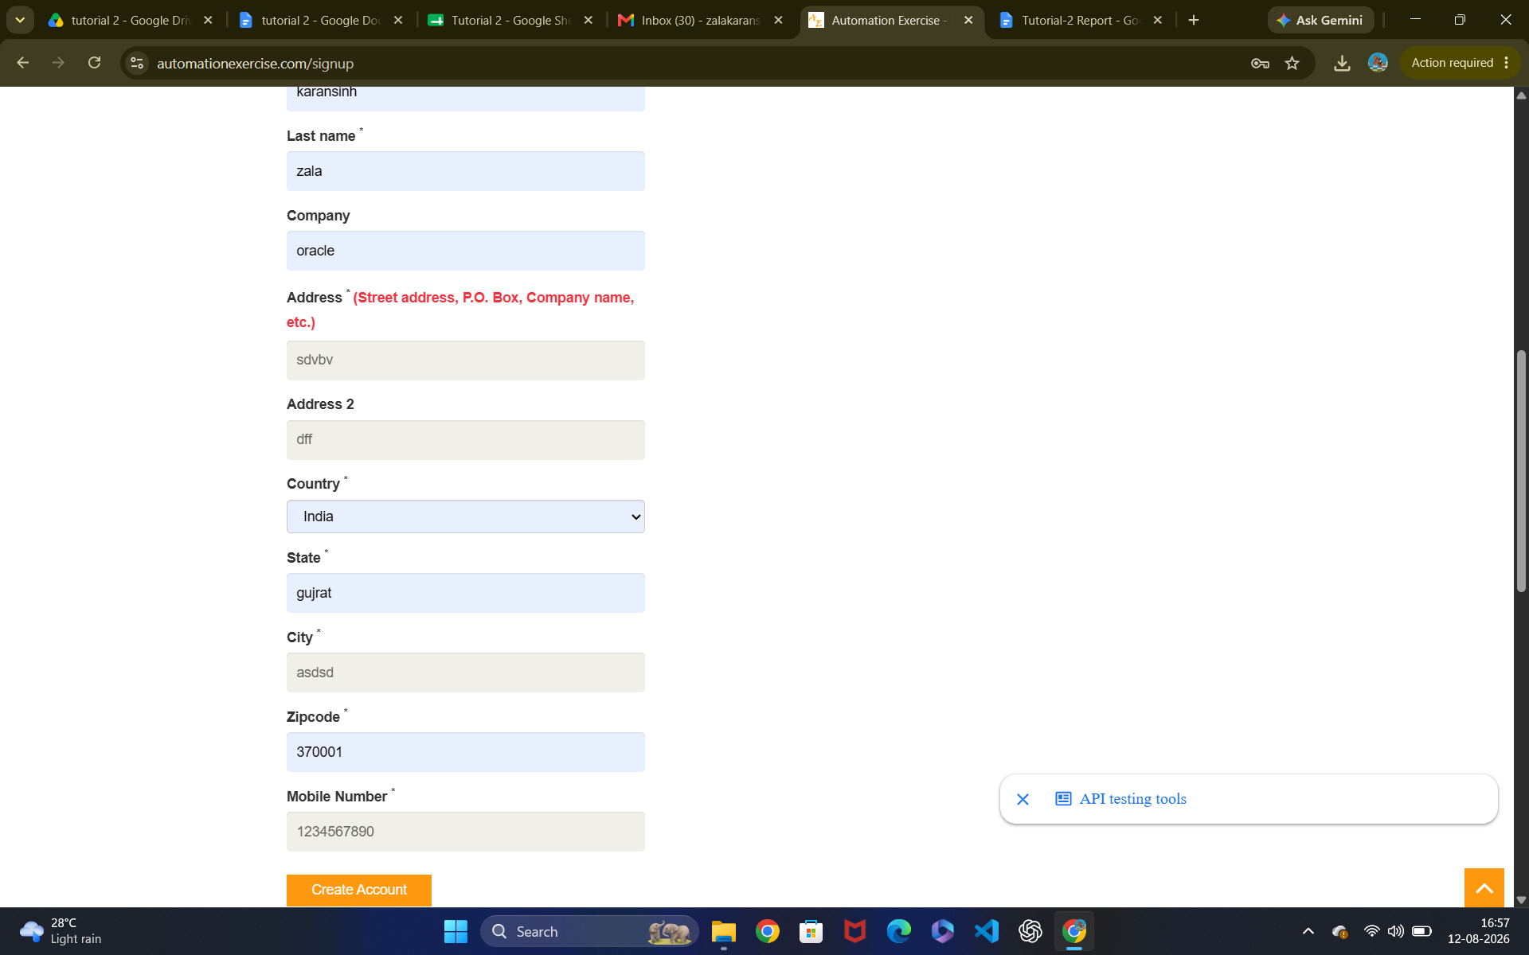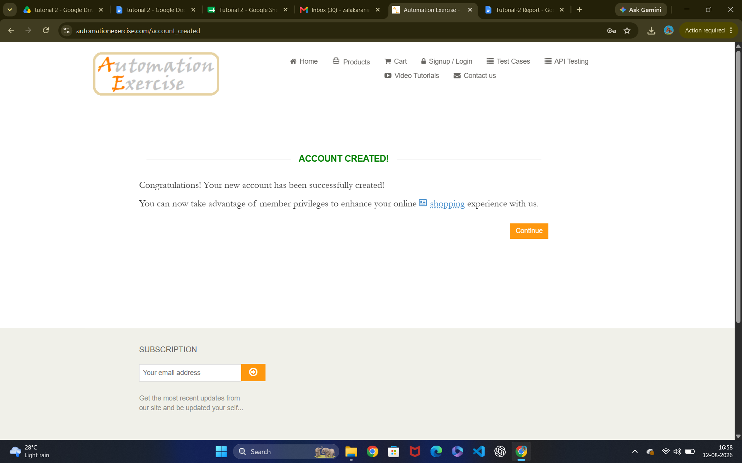
- Scenario ID: 3

Scenario: Existing email registration
Test Steps:
1. Open the Website and register in website
2. Enter username and existing email ID
Screenshots: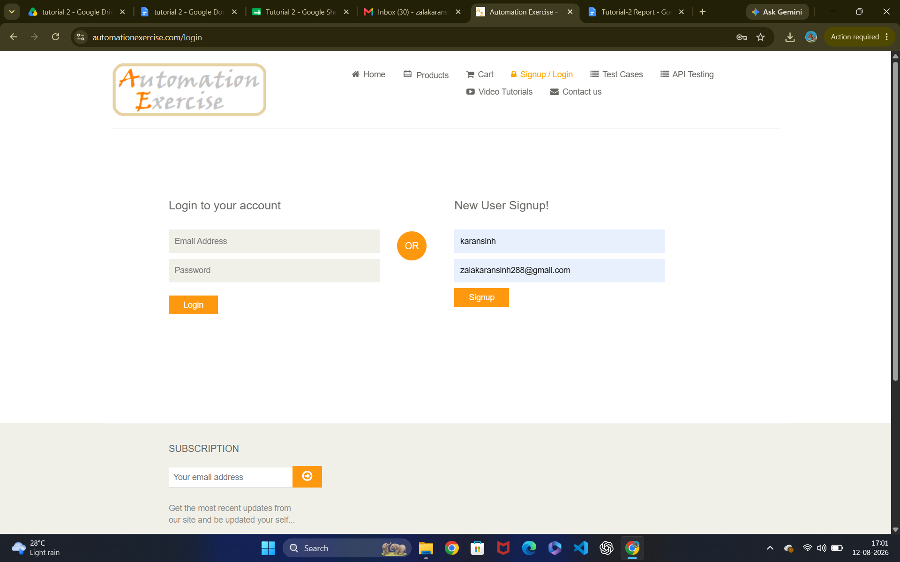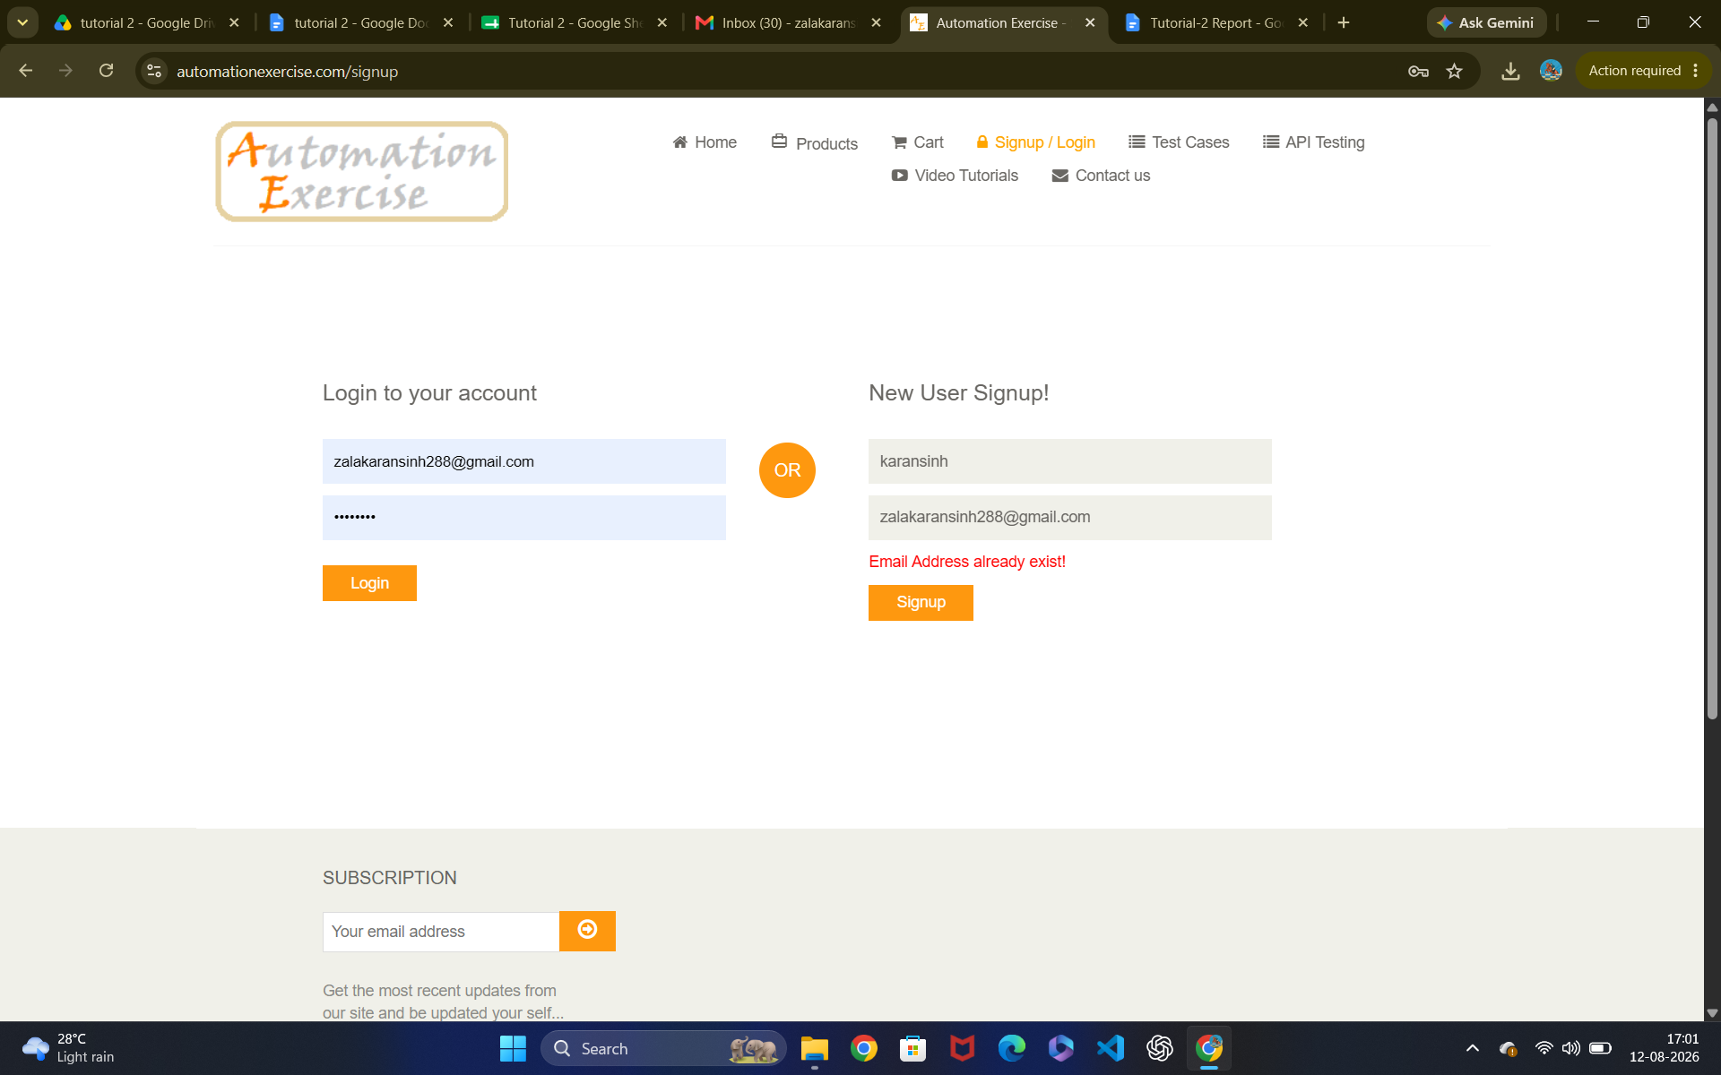
- Scenario ID: 4

Scenario: Valid login
Test Steps:
1. Open the Website and register in website
2. Enter valid email
3.Enter password
4.Click Login
Screenshots: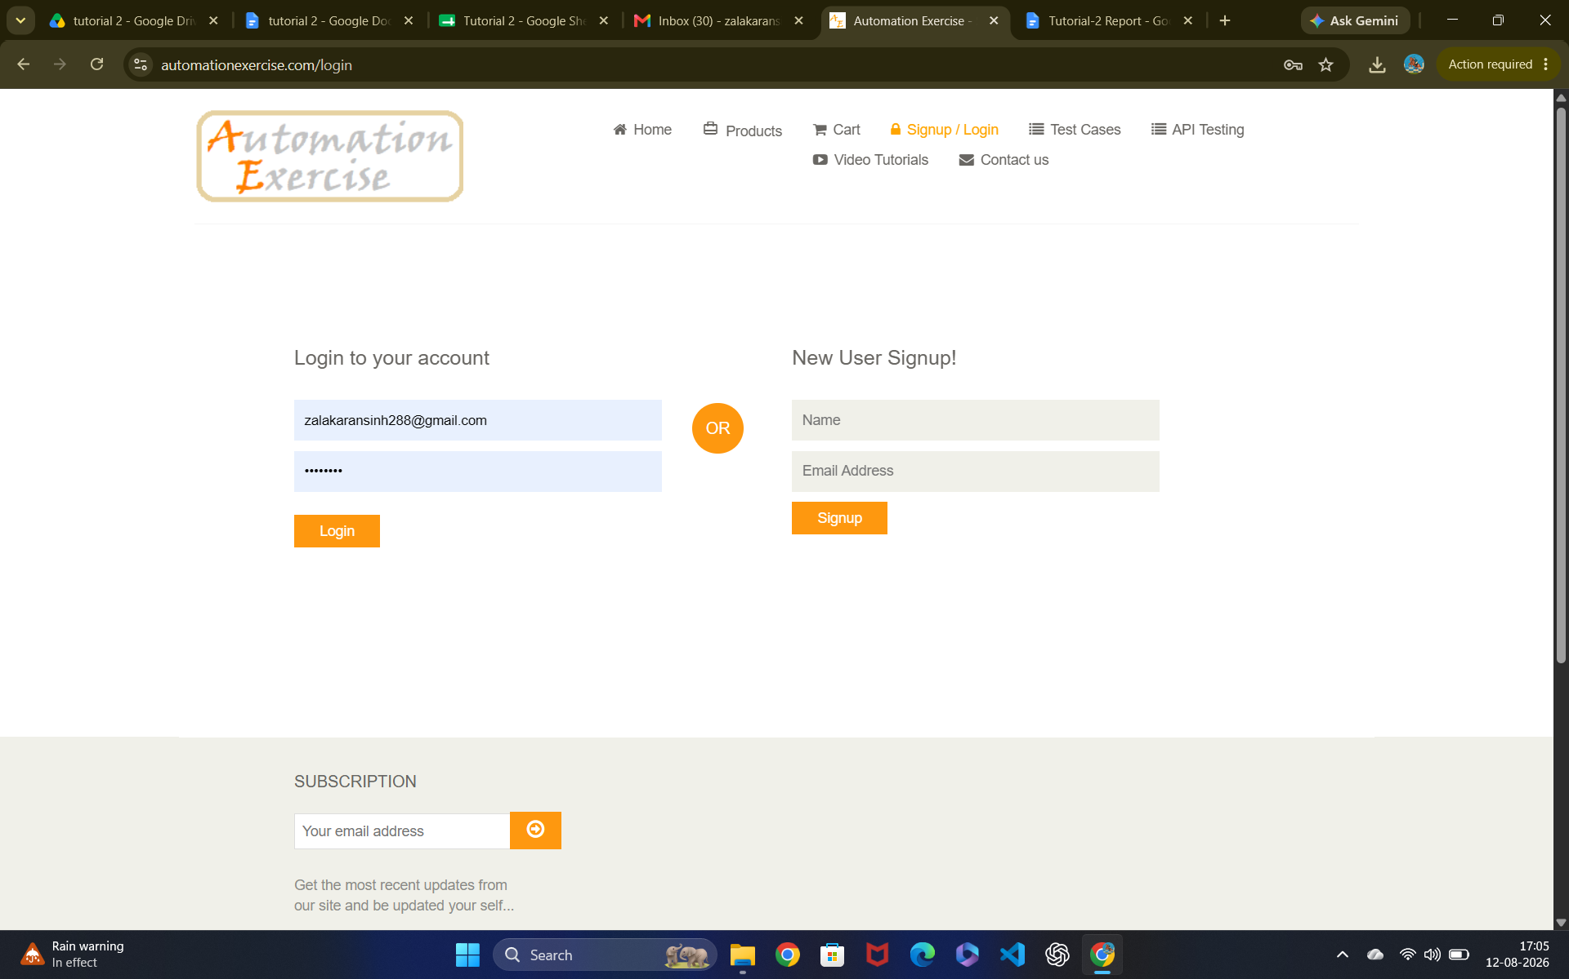
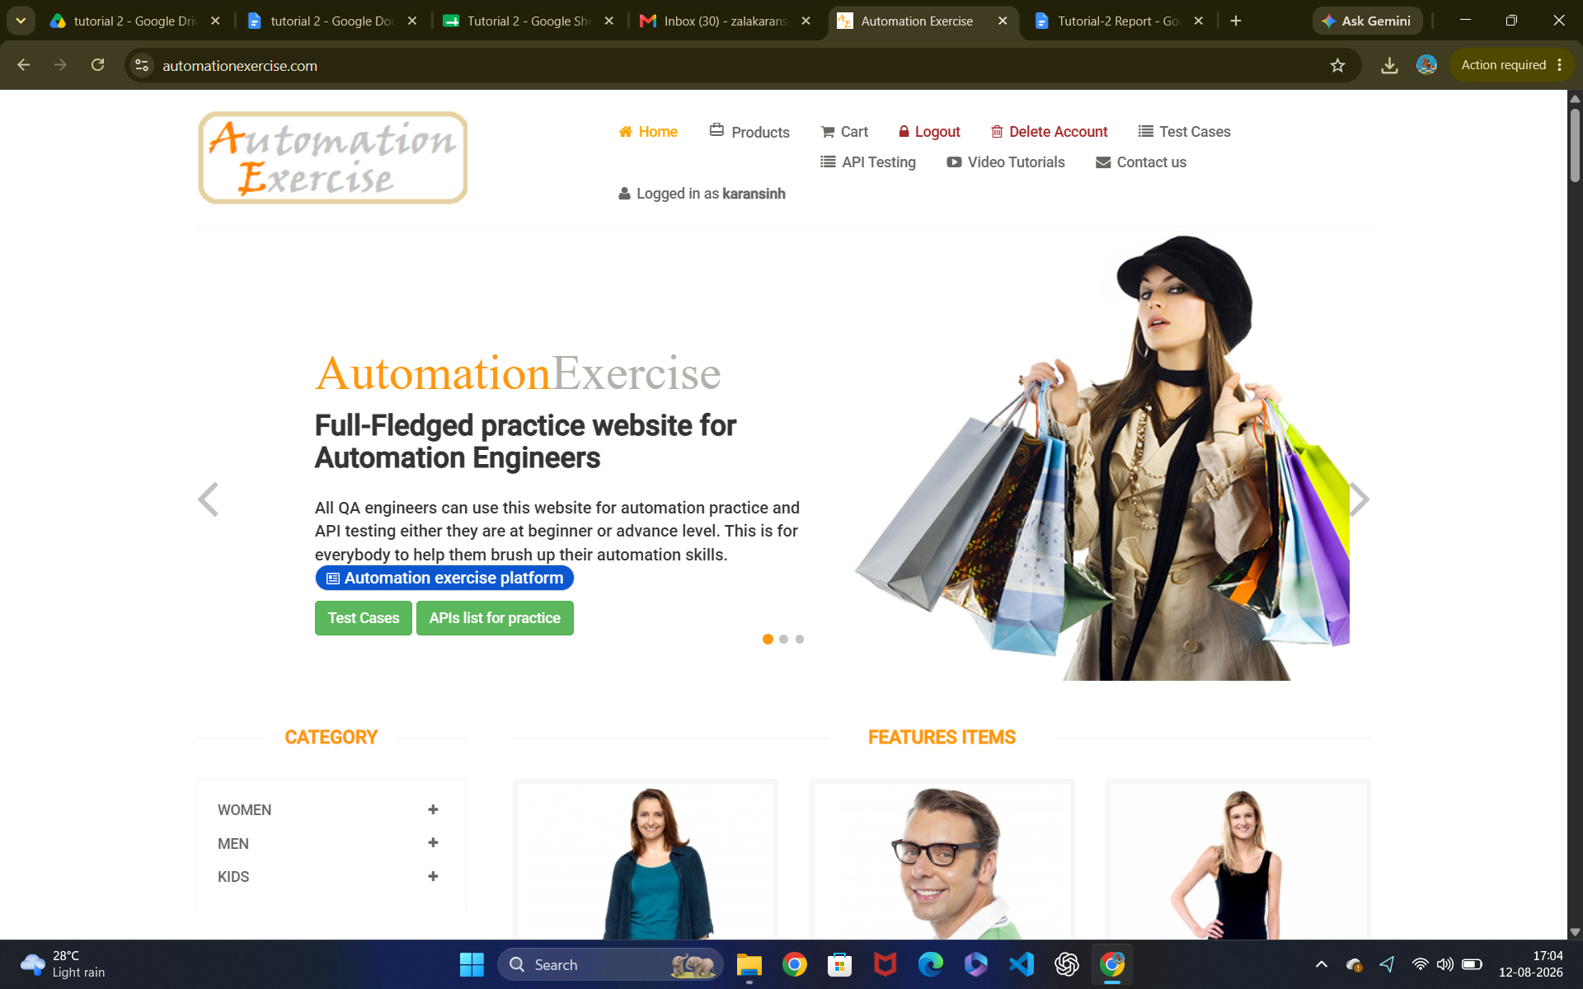
- Scenario ID: 5

Scenario: Invalid email
Test Steps:
1. Open the Website and register in website
2. Enter Invalid email
3.Enter password
4.Click Login
Screenshots:
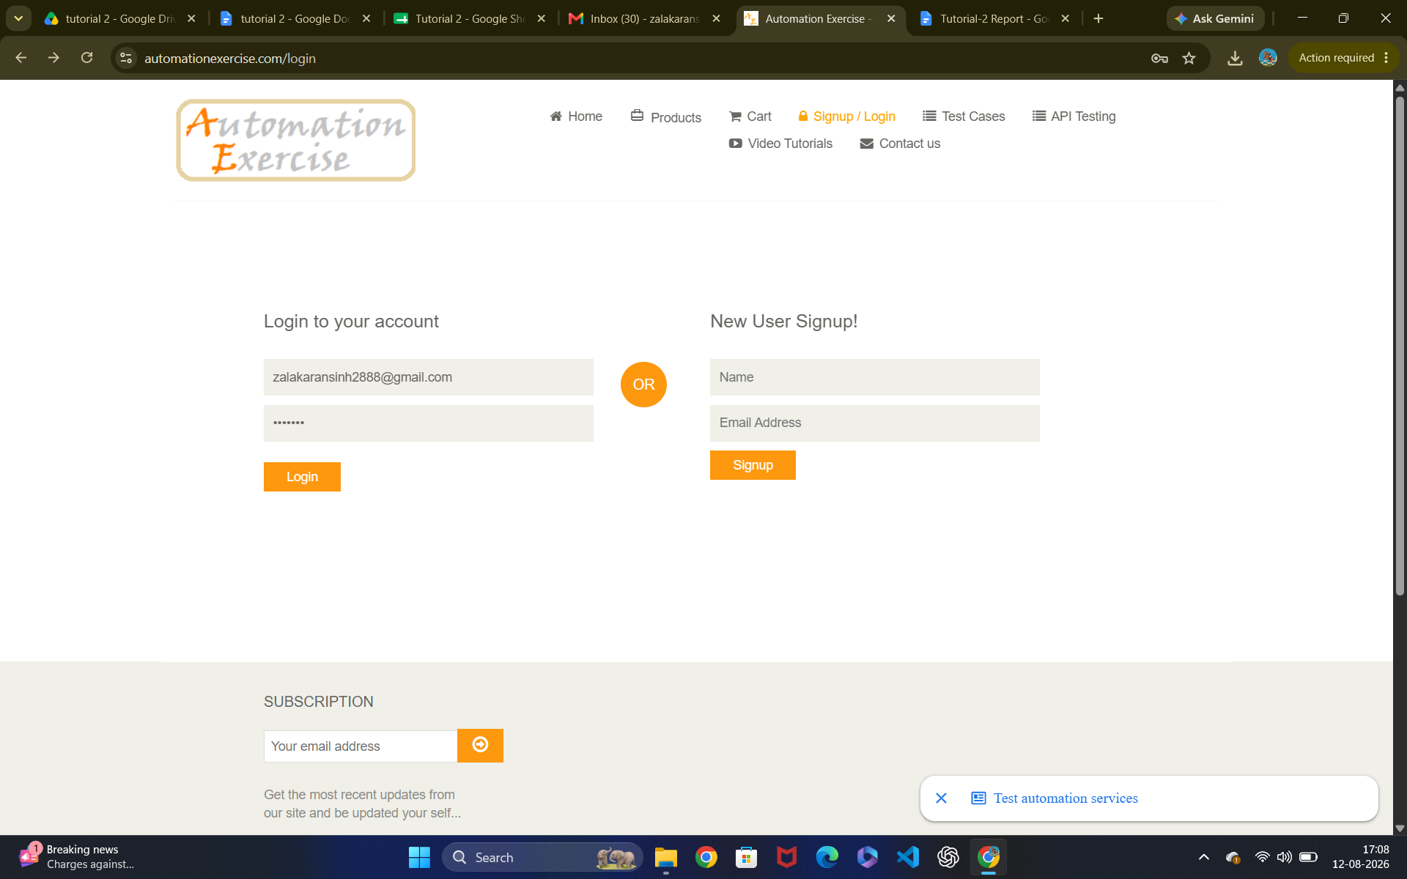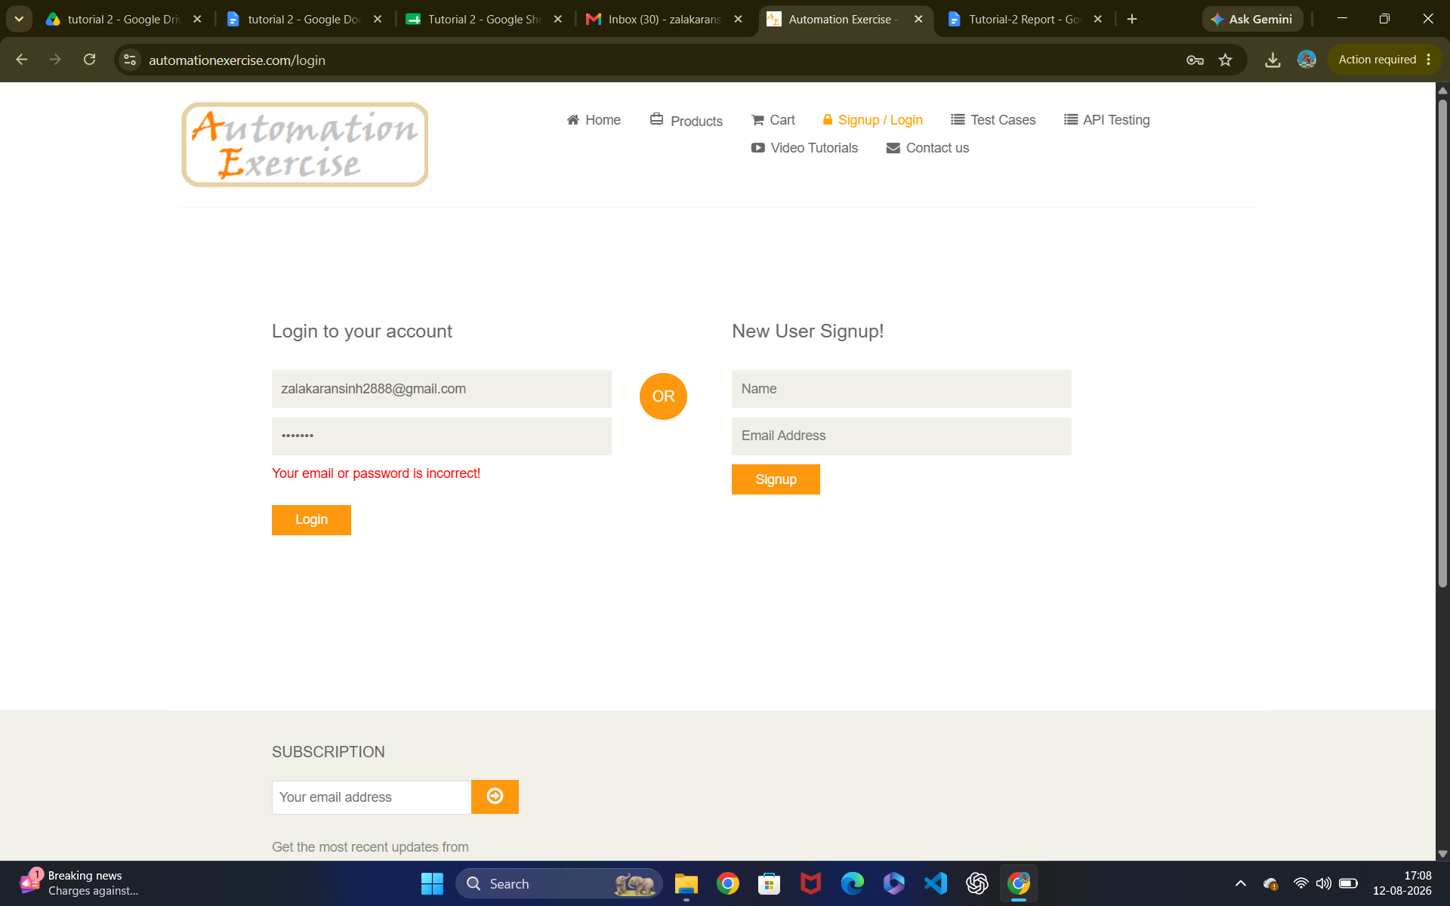

- Scenario ID: 6

Scenario: Invalid password
Test Steps:
1. Open the Website and register in website
2. Enter valid email
3.Enter Invalid password
4.Click Login
Screenshots: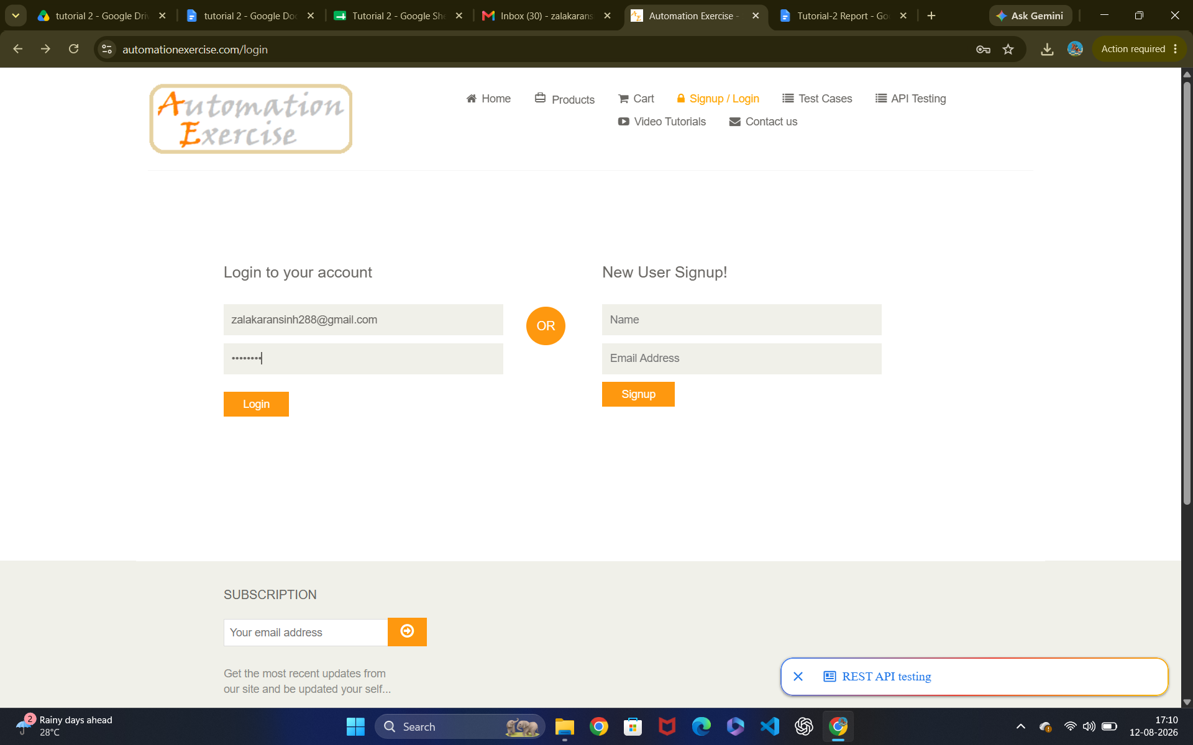 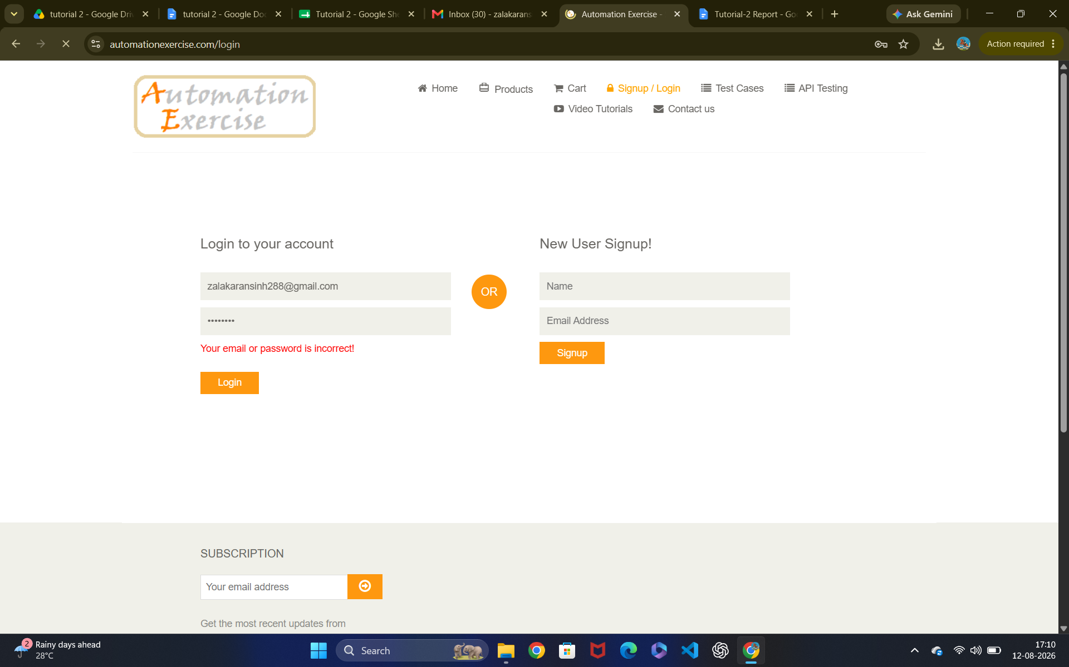

- Scenario ID: 8

Scenario: Blank username
Test Steps:
1. Enter only email address
Screenshots :
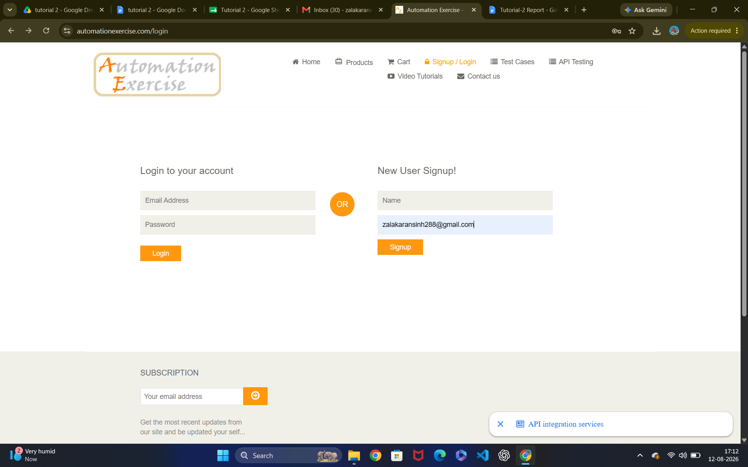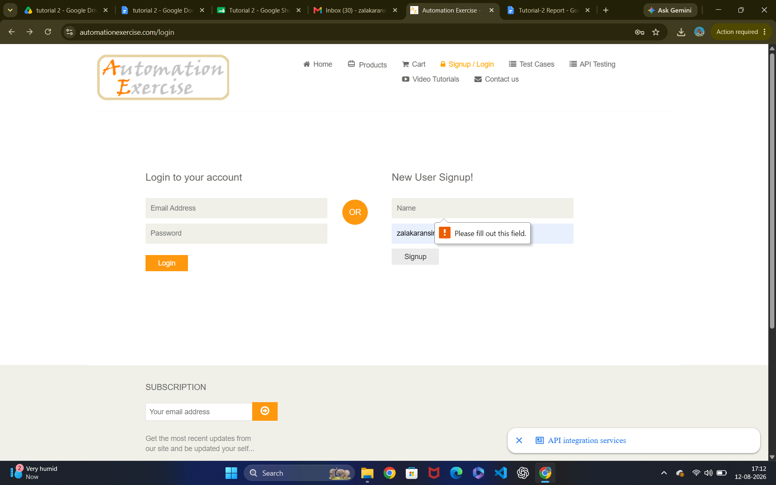
Scenario ID: 7

Scenario: logout
Test Steps:
1. Click logout button

Screenshots:

